“Using carbon taxes to meet an emission target” by Prof. Billy Pizer
On November 8th, “Energy and Environmental Economics” lecture X, organized by Center for Energy Economics and Strategy Studies (CEESS) of Fudan University, was held in conference room 514, School of Economics, Fudan University. Prof. Wu Libo, director of CEESS, has presided this lecture. The lecture named “Using carbon taxes to meet an emission target” was delivered by Prof. Billy Pizer from the Sanford School of Public Policy at Duke University.
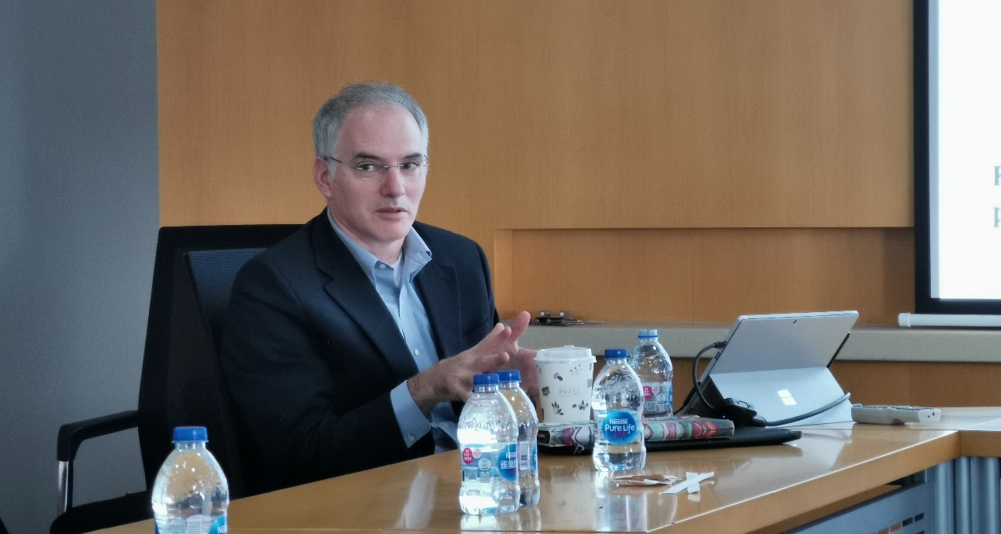
Prof. Billy Pizer joined the faculty of the Sanford School of Public Policy at Duke University in the fall of 2011. He also was appointed a faculty fellow in the Nicholas Institute for Environmental Policy Solutions, a nonpartisan institute at Duke that focuses on finding solutions to some of the nation's most pressing environmental challenges. From 2008 to 2011, Pizer was deputy assistant secretary for environment and energy in the U.S. Department of the Treasury, where he created and led a new office responsible for the department’s role in the domestic and international environment and energy agenda of the United States. Prior to that, Pizer was a researcher at Resources for the Future (RFF), a nonpartisan think tank, for more than a decade. He served as senior economist for the environment at the White House Council of Economic Advisers from 2001 to 2002.
Prof. Pizer shared his recent working paper in this lecture. At first, he stressed the importance of carbon tax policy in carbon dioxide emission reduction. Furthermore, he demonstrated the framework and significance for this research. Specifically, considering the possibility of discontinuity in the demage function, Prof. Pizer pointed out that the emission target could be taken as a breakpoint, so that the function shall be piecewise, which was much closer to the reality. Prof. Pizer also explained possible carbon tax adjustment path, which could be divided into mainly four types: 1. If the actual emissions exceed the emission target, then a higher tax rate would be implemented; 2. Adjust the initial level of carbon tax; 3. Set different growth rate of carbon tax according to the accomplishment of the target; 4. Similar to emission trading system, emission target should be achieved strictly.
Besides, Prof. Pizer assumpted that the carbon emission intensity change and GDP growth followed Markov Process. Using DIEM-CGE model, he simulated the social welfare, average abatement cost and average social demage in different scenarios and compared the simulation results, which exactly help the government find best policy. From the result, what we learned is that carbon tax should be decided to max social welfare, and different forms of social welfare function would lead to different results in policy comparison.
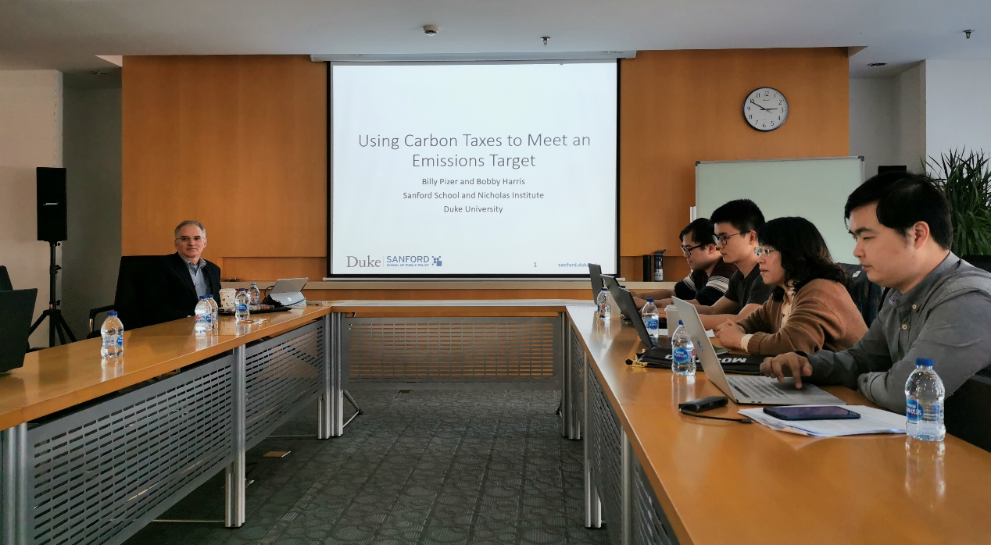
At last, Prof. Pizer answered the questions about his working paper and the lecture came to a successful conclusion. All the teachers and students benefited a lot from this lecture.

